

Consultation Document

The Wales Accord on the Sharing of Personal Information (WASPI) as an approved Code of Conduct

We want your views on a proposed WASPI Code of Conduct and its intended application to the Information Commissioner’s Office (ICO) to become an approved ICO Code of Conduct.

Date of issue: 20/02/2023
Action required: Responses by 28/04/2023

UK General Data Protection Regulation (UK GDPR)

Digital Health & Care Wales will be data controller for any personal data you provide as part of your response to the consultation. Any response you send us will be seen in full by Digital Health & Care Wales staff dealing with the issues which this consultation is about.
In order to show that the consultation was carried out properly, Digital Health & Care Wales intends to publish a summary of the responses to this document. We may also publish responses in full. Normally, the name and address (or part of the address) of the person or organisation who sent the response are published with the response. If you do not want your name or address published, please tell us this in writing when you send your response. We will then redact them before publishing.
You should also be aware of our responsibilities under Freedom of Information legislation.

If your details are published as part of the consultation response, then these published reports will be retained indefinitely. Any of your data held otherwise by Digital Health & Care Wales will be kept for no more than three years.
Your rights
Under the data protection legislation, you have the right:
- to be informed of the personal data held about you and to access it
- to require us to rectify inaccuracies in that data
- to (in certain circumstances) object to or restrict processing
- for (in certain circumstances) your data to be ‘erased’
- to (in certain circumstances) data portability
- to lodge a complaint with the Information Commissioner’s Office (ICO) who is our independent regulator for data protection.

For further details about the information the Digital Health & Care Wales holds and its use, or if you want to exercise your rights under the UK GDPR, please see contact details below:

Data Protection Officer:
Digital Health and Care Wales
Tŷ Glan-yr-Afon
21 Cowbridge Road East
Cardiff
CF11 9AD DHCW.InformationGovernance@wales.nhs.uk
The contact details for the Information Commissioner’s Office are:
Wycliffe House
Water Lane
Wilmslow
Cheshire SK9 5AF
Tel: 0303 123 1113
Website: https://ico.org.uk/

Contents

WASPI Background 4
Proposed code of conduct and intended outcomes 6
How to respond 10
Consultation Response Form 12

WASPI Background

What is this consultation about?
This consultation seeks your views on a proposal for the Wales Accord on the Sharing of Personal Information (WASPI) framework to apply to become an approved Information Commissioners’ Office (ICO) Code of Conduct under the provisions of article 40 of the UK General Data Protection Regulation.
The code will build upon the existing framework with the intention of the code offering members and their stakeholders, including the public, additional assurance around organisational practices of data sharing.
Organisations directly concerned with the health, education, safety, crime prevention and social wellbeing of citizens of Wales have embraced the Wales Accord on the Sharing of Personal Information (WASPI) as a tool to help them share information effectively and lawfully.
The WASPI framework is managed by Digital Health and Care Wales (DHCW) and supported and funded by Welsh Government.
We are consulting on:
- whether the proposed code is clear and enhances the existing WASPI framework.
- whether the requirements of prospective code members, which are necessary to make the code compliant with the Information Commissioner’s Office code of conduct expectations, are clear.
- whether organisations would intend to sign up to become a code member.

Background of WASPI
Sharing of personal data is an essential element of delivering effective services to citizens.
The existing Wales Accord on the Sharing of Personal Information (WASPI) is a framework for those organisations that hold information about living individuals (personal data) and who consider it appropriate or necessary to share it with others.
The current WASPI arrangements consist of a voluntary framework that has been available for over a decade. It was established to address challenges faced by stakeholders who needed to share the personal data of citizens to offer care, treatment, support, education and protection. The various iterations of the Accord have drawn on the legislation and available guidance, such as the Information Commissioner’s Data Sharing Code of Practice, to introduce a set of principles that signatories agree to apply when sharing personal data.

WASPI provides a framework which builds confidence that personal data can, and may, be shared to deliver services that benefit people in Wales. The development of standardised templates for information sharing agreements, with an associated quality assurance process, underpins the principles set out in the Accord and has helped organisations to set out how their data sharing arrangements are lawful and appropriate.
WASPI has extensive support, including public statements of support from the Information Commissioner and sponsorship from Welsh Government. At the time of writing, in November 2022, over 750 organisations were signatories to existing WASPI Accord, including:

- All Welsh Health Boards and Trusts.
- All Welsh Local Authorities.
- All Welsh Police Forces and associated Police and Crime Commissioners.
- The National Probation Service (Wales).
- All Welsh Fire and Rescue Services.
- Education providers (schools, colleges, early years providers and others).
- General Medical Practices.
- Schools.
- Voluntary sectors organisations and charities.
- Housing Associations.

Proposed code of conduct and intended outcomes

The code seeks to achieve:
- Addressing key risks to effective and lawful information sharing of personal data by: Reinforcing WASPI as the information sharing framework in Wales to support data protection compliance.

- Ensuring the consistent application of WASPI principles through an emphasis on the importance of the quality assurance processes and assurances that data sharing documentation is regularly reviewed.

- Maintaining the relevance and accuracy of data sharing arrangements by insisting they are regularly reviewed and updated.

- Requiring code members to demonstrate good governance and accountability.
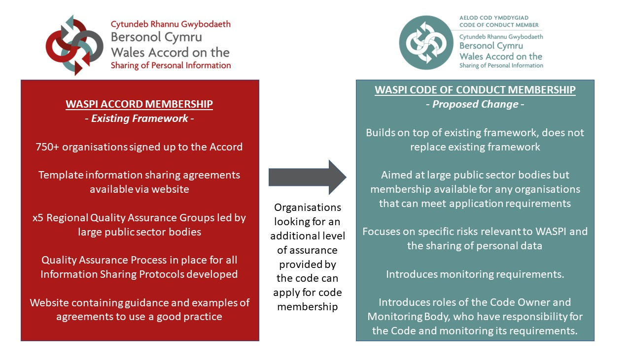
The code builds upon the existing framework with the intention of the code offering members and their stakeholders, including the public, additional assurance around organisational practices of data sharing.

The code seeks to ensures consistent application of principles for sharing of data, ensures relevant agreements are reviewed and updated and ensures good governance and accountability aligned to the ICO data sharing code of practice.
The code would provide an approved assurance model for organisations to confidently document the lawful sharing of personal and sensitive data across multiple sectors.

Wide support for WASPI has helped organisations from different sectors to adopt a consistent approach to sharing personal data, notably the framework played a pivotal role is supporting documented data sharing throughout the covid-19 pandemic, with Wales being the only UK nation to have consistent documentation to support data sharing arrangements supporting citizens.
Code membership, and the associated monitoring of requirements, provides assurance and builds confidence to the public, organisations and their stakeholders that information sharing practices which support provision of services are compliant in accordance with data protection requirements.
In becoming an approved Information Commissioner’s Office Code of Conduct, the code would offer key assurances and protection to prospective code member organisations with the support of the Information Commissioner’s Office, including:

- ensuring the consistent application of data sharing principles and compliance with the UK GDPR through an emphasis on the importance of the quality assurance processes.

- maintaining the relevance of agreements by insisting they are regularly reviewed and updated will provide increased confidence and transparency to citizens and enable organisations to meet obligations of the UK GDPR.

- encouraging code members to demonstrate a level of governance and accountability will provide assurances to the ICO that code members have compliant data sharing processes in place.
Adherence to the proposed code would not mean that a code member is compliant with the whole UK GDPR, only that of the elements that fall within the scope of the code itself. Compliance to the code standards will support organisations with being able to demonstrate their controls in the event of an approved code member organisation being potentially subject to regulatory action.
The code would not replace or contradict any other national legislation which applies to the sharing of personal data. The code supports organisations with ensuring they have documented mechanisms to set out lawful basis of data sharing which will relates to applicable cross sectoral national legislation and can assist organisations with mitigating against risks of potential data breaches.

What we are proposing
Article 40(4) of the UK GDPR states that codes of conduct shall contain mechanisms that enable a monitoring body to carry out mandatory monitoring of compliance with a code’s provisions.
Digital Health and Care Wales (DHCW) is a Special Health Authority and statutory body established under statutory instrument 2020 No. 1451 (W.313), ‘The Digital Health and Care Wales (Establishment and Membership) Order 2020’. DHCW and its preceding organisation, NHS Wales Informatics Service (NWIS), have provided a central support function for WASPI since 2010, with funding for this service incorporated into DHCW’s core financial model.

As the owners of the WASPI framework and with extensive experience of maintaining and developing WASPI across all sectors, representing and liaising with stakeholders to promote the framework, we are proposing that DHCW to be the appropriate code owner with the WASPI Support Team becoming the Monitoring Body with visibility of code member compliance being provided to the WASPI Management Advisory Board and DHCW Executive Management Board. The full responsibilities of the Monitoring Body are set out within the draft code.
To provide assurance of the added value that the Code would provide, the WASPI Code of Conduct would introduce an annual assessment for code members known as the Governance and Information Risk Assurance (GIRA). The code members submission of the GIRA would be reviewed by the monitoring body to ensure that they continue to meet the requirements of a code of conduct member.
The proposed GIRA which forms part of the wider WASPI Code of Conduct Audit Strategy, in intended to assess specific areas relating to data sharing. It has been developed with other regulatory and assurance models, pertinent to public sector considered, to ensure that duplication of effort is minimised, or to work alongside such requirements where possible to enable the WASPI annual GIRA to support organisations with evidence to existing requirements such as governance assurance, audit evidence, cyber essentials, and Information Governance toolkit submissions.
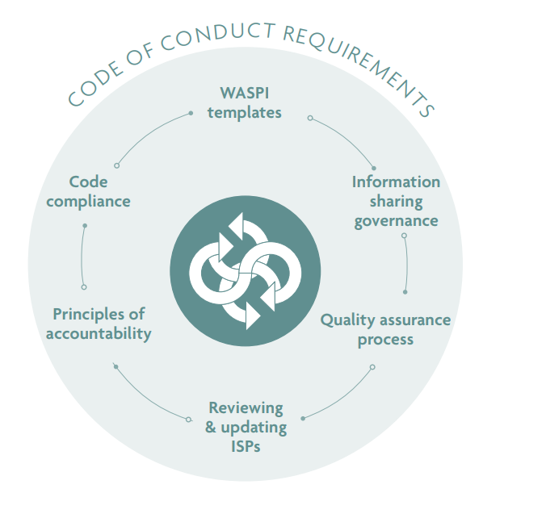

Timeframes & intended next steps
Subject to the views submitted during this consultation exercise, it is intended that the final version of this code will be formally taken forward to the Information Commissioner’s Office for consideration as to whether they will approve the WASPI Code of Conduct.
Any views provided as part of this consultation will be considered as part of the final version of the Code of Conduct with a summary provided of all considerations.
In the event of the code being accepted by the Information Commissioner’s Office, an implementation plan and further guidance will be issued to stakeholders.

How to respond
We would welcome as much feedback on the proposals, this can be provided through completion of the consultation questionnaire form at the back of this document which can be emailed to waspiservice@wales.nhs.uk or through completing the online form.

Further information and related documents
Large print, Braille and alternative language versions of this document are available on request.

Contact details
For further information:
Dave Parsons
Information Sharing & Integration Governance Manager
Digital Health & Care Wales
Information Governance
Tŷ Glan-yr-Afon
21 Cowbridge Road East
Cardiff
CF11 9AD
Email: Dave.Parsons@wales.nhs.uk

This document is also available in Welsh

Consultation Response Form

Your name:

Organisation (if applicable):

email / telephone number:

Your address:

Question 1: Please explain whether you believe the proposed code offers additional assurances on data sharing for citizens and what benefits you believe this can provide to your organisation if applicable.
Please enter here:

Question 2: The proposed code sets a number of monitoring mechanisms which will be implemented to ensure that a code member remains compliant. Do you have any views on the intended monitoring mechanisms or any related issues which we have not specifically addressed, please use this space to report them:
Please enter here:

Question 3: Does the code clearly set out the roles of the code owner and monitoring body?
Please enter here:

Question 4: How does your organisation feel being subject to monitoring mechanisms and evaluation, and the implications of not meeting requirements resulting in the potential for code membership to be revoked?
Please enter here:

Question 5: Are there any barriers which may prevent your organisation from signing up to become a code member and would your organisation be intended to become a code member?
Please enter here:

Question 6: Code membership will be subject to annual Governance & Information Risk Assurance (GIRA) and a committed 3-year audit requirement. Are there any barriers to the intended GIRA or any standards which you feel could be implemented to assist your organisation with demonstrating meeting the requirements of code membership?
Please enter here:

Question 7: Do you agree with the proposal to create WASPI as an approved ICO code of conduct? Please explain your reasoning.
Please enter here:

Responses to consultations are likely to be made public, on the internet or in a report. If you would prefer your response to remain anonymous, please tick here:

This document is also available in Welsh

