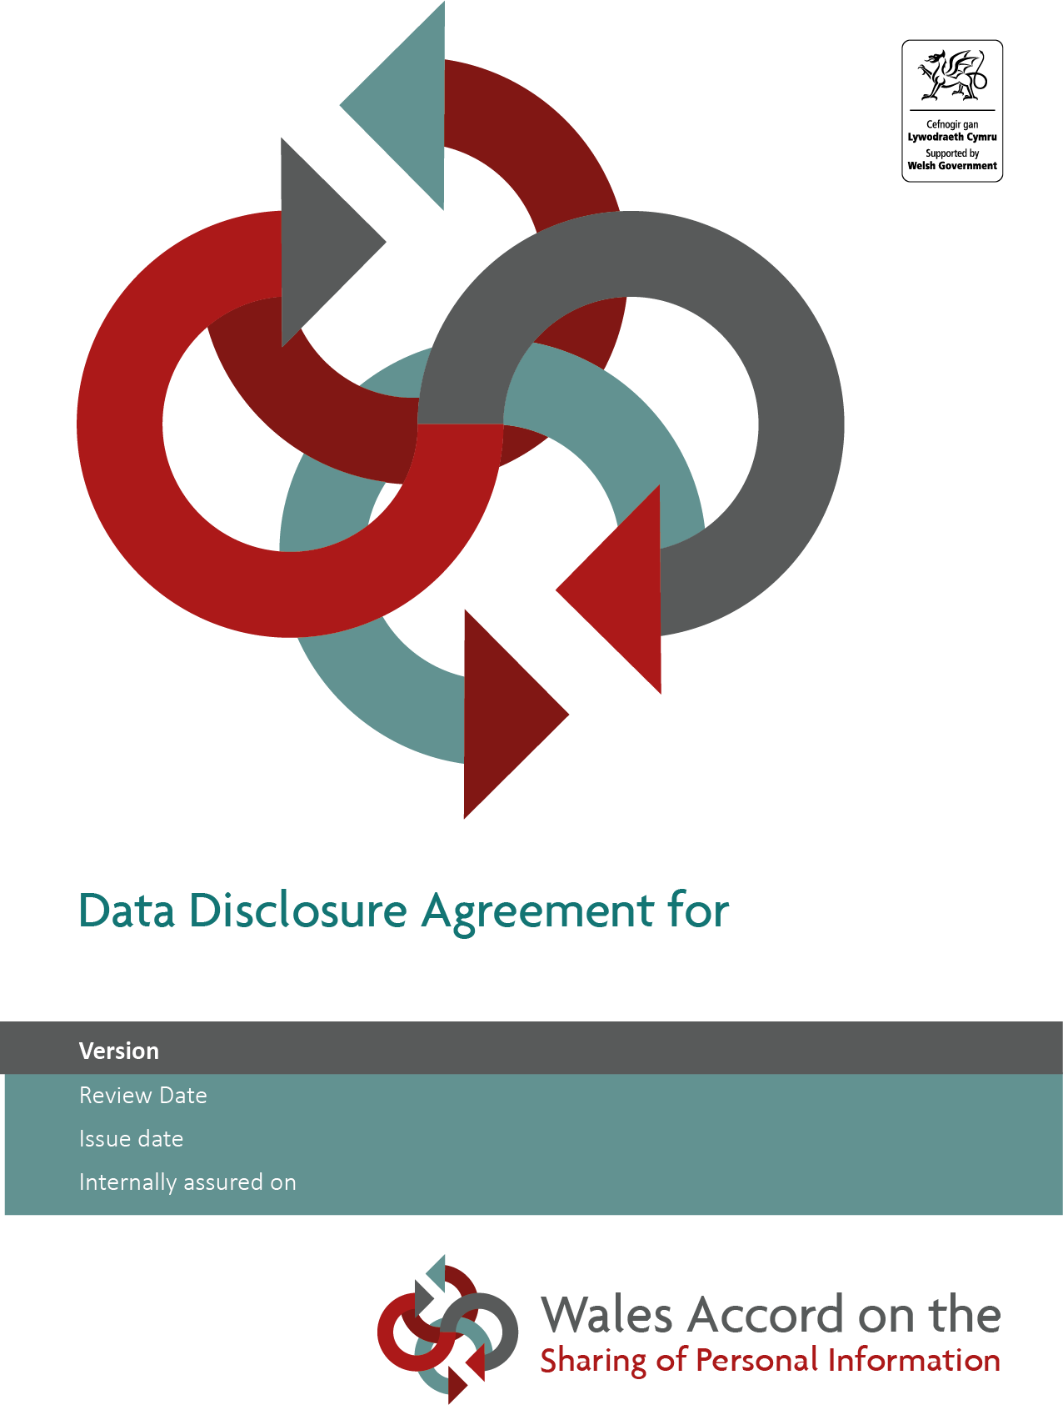

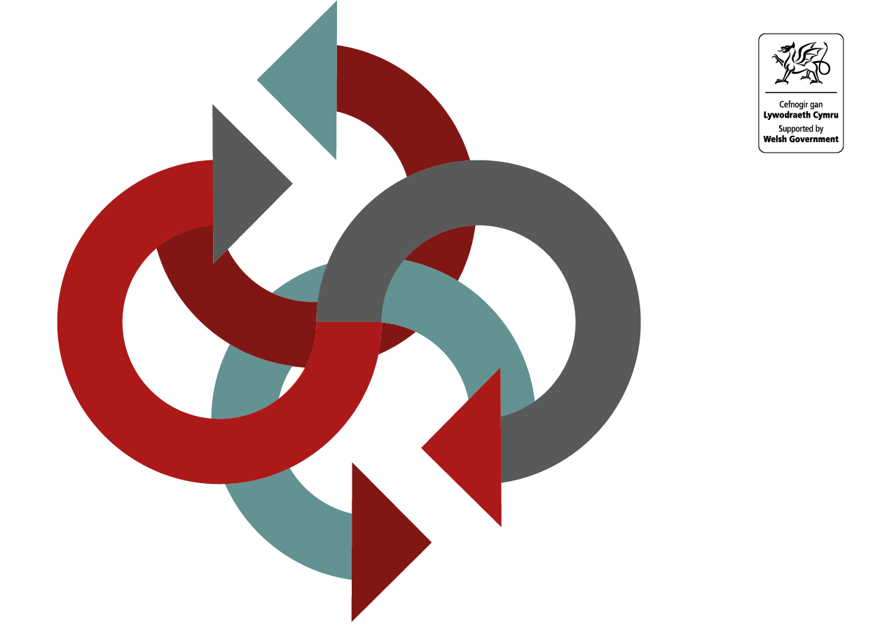
[Insert date here]
[Insert date here]
[Insert date here]
[Insert details here]
[Insert details here]

Further information on how a DDA should be developed in line with the WASPI framework is contained within the
Guide on the Development of a Data Disclosure Agreements

Further guidance may be sought from the
WASPI Service Integration and Development Team at: www.waspi.gov.wales

Note: This page can be removed once the DDA development has commenced

Data Disclosure Agreements are intended for use when personal data is to be disclosed (i.e. passed one way) from one Data Controller to another for a specific purpose. DDAs are not intended for use in instances where the disclosure is from a Data Controller to a Data Processor and do not replace the requirement for appropriate contracts.
Information Sharing Protocols (ISPs) should be developed to document practices involving the regular, reciprocal sharing (i.e. information flows back and forth between organisations) of personal information between Data Controllers. Separate guidance and templates are available on the WASPI website to assist with the ISP development process.

Contents

1 Introduction 2
2 Purpose of Disclosure 2
3 Partners to this agreement 2
4 Lawful basis 2
5 Data to be Disclosed 3
6 Information Security 3
7 Detail of disclosure 4
8 Data Subjects’ Rights 4
9 Review, Breaches and Termination of this Agreement 5
10 Agreement Signature 6
11 Appendix A – Glossary of Terms 7

Introduction
  - [Insert description of the specific disclosure the DDA is intended to support]
  - This Data Disclosure Agreement has been written in accordance with the principles contained within the Wales Accord on the Sharing of Personal Information (WASPI).
  - This DDA is intended to help partner organisations understand what data can be disclosed for the stated purpose(s). It also provides assurance that the partners have considered the requirements of data protection legislation.

Purpose of Disclosure
  - Personal data is shared for the purpose of [insert purpose of disclosure. This can be taken from your Data Protection Impact Assessment, if one is required].

Partners to this agreement
  - Data is disclosed by [insert name of disclosing organisation] to [insert name of recipient organisation(s)]
  - Partners to this agreement may only use the personal data disclosed to them under this agreement for the specific purpose(s) set out in this document. The data will not be exchanged with, or passed to, any non-related areas of the receiving organisation or any third parties without prior approval of the originating partner.
  - In line with the requirements of data protection legislation, partner organisations will ensure data subjects are informed how their personal data will be used.
  - The partner organisations will regularly monitor and review the use of this DDA to ensure data is disclosed effectively and appropriately.

Lawful basis
  - For the purpose of the Data Disclosure Agreement, the lawful bases for processing are as follows:
HOW TO USE THE TABLES
The following tables are designed to allow partners to this agreement to highlight the lawful bases relevant to the sharing described in this DDA.

Organisations should ensure that they meet the requirements for each legal basis selected, this includes complying with UK GDPR Article 7 when relying on consent as a legal basis (UK GDPR Article 6(1)(a) and Article 9(2)(a)) and having an Appropriate Policy Document in place where relevant.

Please take advice from your Data Protection Officer or equivalent on what legal basis are appropriate. Definitions of the terms referenced below can be found at Appendix A.

GENERAL PROCESSING
(as defined by the UK General Data Protection Regulation (UK GDPR))
Article 6 of UK GDPR [insert specific lawful basis]
If processing involves special categories of data, Article 9 of UK GDPR [insert specific lawful basis]
If processing involves processing of personal data relating to criminal convictions and offences
[The processing is carried out under the control of an official authority / competent authority (see table below for Processing for Law Enforcement Purposes),
and/or
Outline the specific condition under Part 1, 2 or 3 of Schedule 1 of the Data Protection Act 2018]

PROCESSING FOR LAW ENFORCEMENT PURPOSES
(processing by competent authorities as defined by the Data Protection Act 2018 (DPA18))
In accordance with DPA18 section 35(2), [insert relevant condition (a) or (b)]
In the case of sensitive processing, [insert relevant condition; either
DPA18 section 35(4), or
DPA18 section 35(5) and the specific schedule 8 condition, where required]

Data to be Disclosed
  - Describe the categories of personal data to be disclosed. Do not include actual personal data in this agreement:
- [Insert list of categories of data]
  - Partners to this agreement will ensure that all data disclosed or collected is adequate, relevant, accurate, up to date and limited to what is necessary to meet the stated purpose.

Information Security
  - Partners to this agreement will ensure that individual access to the data is limited to those who have a legitimate purpose to view, use or otherwise access it. Appropriate measures will be taken to ensure that the confidentiality of the data is maintained at all times.
  - Partners to this agreement must have an appropriate and adequate security framework.
  - Practitioners carrying out the functions outlined in this DDA should make themselves aware of, and adhere to, their organisation’s data protection, confidentiality and information security policies and procedures.
  - All partners must ensure that adequate and appropriate training on the subjects of data protection, confidentiality and information security is provided to all staff with access to personal data.

Detail of disclosure
Description | Detail
Source of Data | [Detail the originating computer system, or paper system and the relevant directorate/department/team]
Methods of Transfer | [Detail specific agreed methods of secure transfer, including:  Electronic methods of transfer, such as secure portals, encryption, non- electronic methods of transfer such as recorded delivery, hand delivery, and any forms/letters/paper documents used to transfer data]
Destination of Data | [Detail the computer system or manual systems that will hold the disclosed data and the directorate/department/team responsible for it]
Frequency | The data will be disclosed ☐ Daily ☐ Weekly ☐ Monthly [Amend where appropriate]
Retention period | [Set out the retention period or the criteria used to define the retention period]

Data Subjects’ Rights
  - Data protection legislation provides various individual rights for data subjects. Advice on how these rights should be met should be sought from each organisation’s Information Governance representative, Data Protection Officer or equivalent. Specific guidance on these rights is available on the Information Commissioner’s website; www.ico.org.uk
  - Partners should ensure that data subjects are informed how and why their personal information will be processed and who it is shared with (the Right to be Informed). Ideally, this information – often provided in what is commonly referred to as a privacy notice - will be provided at the first point of contact. It can be part of a registration / consent form or a standalone document.
  - Partners will ensure that all information is clear and particular care taken when relying on consent as the lawful basis for sharing information, or where working with children, as there are additional requirements to consider. Further information on the ‘Right to be Informed’ is available on the Information Commissioner’s website; www.ico.org.uk
  - All partners will have in place the appropriate policies and procedures to uphold the confidentiality, integrity and availability of personal information with specific reference to the retention, storage and disposal of records.
  - Partners will deal with requests for the information referenced in this DDA in accordance with each organisation’s relevant policies and procedures.
  - Each partner will put in place a formal procedure through which data subjects, partner organisations and practitioners can direct any complaints regarding the data disclosed documented in this DDA.
  - There is an expectation that the organisations involved in this DDA will work together to keep each other informed of any complaints or requests for information received from data subjects or third parties. The organisations will also keep each other informed of any problems, amendments or requests for erasure associated documented in this DDA and there is an expectation that they will collaborate to develop and improve these practices.

Review, Breaches and Termination of this Agreement
  - This agreement will be reviewed two years from signing this document or sooner, if appropriate.
  - Breaches of this agreement should be reported to the partner organisations which may result in the information sharing set out in the agreement ceasing.
  - Partners to this agreement will determine the responsibilities following termination of this agreement, including the deletion of shared data or its return to the organisation that supplied it originally.

Agreement Signature

Disclosing Organisation
Name
Position
Date
Signature
Recipient Organisation
Name
Position
Date
Signature

Appendix A – Glossary of Terms
Term | Definition
Appropriate Policy Document | The Data Protection Act 2018 outlines the requirement for an Appropriate Policy Document to be in place when processing special category and criminal offence data under certain specified conditions.  Detail on Appropriate Policy Documents can be found in Schedule 1, Part 4 of the DPA 18 and Section 42 of the DPA 18 for competent authorities.
Data Protection Act 2018 | The UK’s third generation of data protection law replaces the previous Data Protection Act 1998. The 2018 Act accepts the standards and obligations set by UK GDPR and, where UK GDPR allows, makes specific provisions relevant to the UK.  The 2018 Act also transposes EU Data Protection Directive 2016/680 (Law Enforcement Directive) into domestic UK law.  It is important the UK GDPR and the DPA 2018 are read side by side.
Data Protection Officer | Certain categories of organisation, including any public body or authority (except courts in their judicial capacity) are required to designate a suitably qualified Data Protection Officer (DPO). The tasks of the DPO are set out in Article 39 of UK GDPR.
Data subject | A ‘data subject’ is an identified or identifiable natural person. Organisations may refer to data subjects as service users, patients, clients, citizens, etc but for consistency, WASPI framework documentation refers to data subjects.
UK GDPR | The UK General Data Protection Regulation (UK GDPR) lays down laws relating to the protection of natural persons with regard to the processing of personal data and rules relating to the free movement of personal data. This Regulation protects fundamental rights and freedoms of natural persons and in particular their right to the protection of personal data.
Law Enforcement Purposes | The purposes of the prevention, investigation, detection or prosecution of criminal offences or the execution of criminal penalties, including the safeguarding against and the prevention of threats to public security. (DPA 2018 Part 3, Chapter 1, Section 31)
Personal data | ‘personal data’ means any information relating to an identified or identifiable natural person (‘data subject’); an identifiable natural person is one who can be identified, directly or indirectly, in particular by reference to an identifier such as a name, an identification number, location data, an online identifier or to one or more factors specific to the physical, physiological, genetic, mental, economic, cultural or social identity of that natural person.
Personal data about criminal convictions, offences or related security measures | This includes personal data which relates to the alleged commission of offences by the data subject, or proceedings for an offence committed or alleged to have been committed by the data subject or the disposal of such proceedings, including sentencing. (DPA 2018 Section 11(2))
Personal identifiers | A set of basic personal details that allow partner organisations to identify a data subject.
Personal information | Includes information falling within the definition of ‘personal data’ and information about deceased individuals. Data protection legislation does not apply to information about deceased individuals but such information needs to be treated confidentially and WASPI should be applied to this information.
Practitioner | An inclusive term that refers to those involved in the care, education, welfare of data subjects; ie those who provide a public service.
Processing personal data | ‘processing’ means any operation or set of operations which is performed on personal data or on sets of personal data, whether or not by automated means, such as collection, recording, organisation, structuring, storage, adaptation or alteration, retrieval, consultation, use, disclosure by transmission, dissemination or otherwise making available, alignment or combination, restriction, erasure or destruction.’ (UK GDPR Art 4(2))
Special categories of data / sensitive data | Processing of personal data revealing racial or ethnic origin, political opinions, religious or philosophical beliefs, or trade union membership, and the processing of genetic data, biometric data for the purpose of uniquely identifying a natural person, data concerning health or data concerning a natural person's sex life or sexual orientation. (UK GDPR Art 9(1))
[Insert further terms as appropriate]

