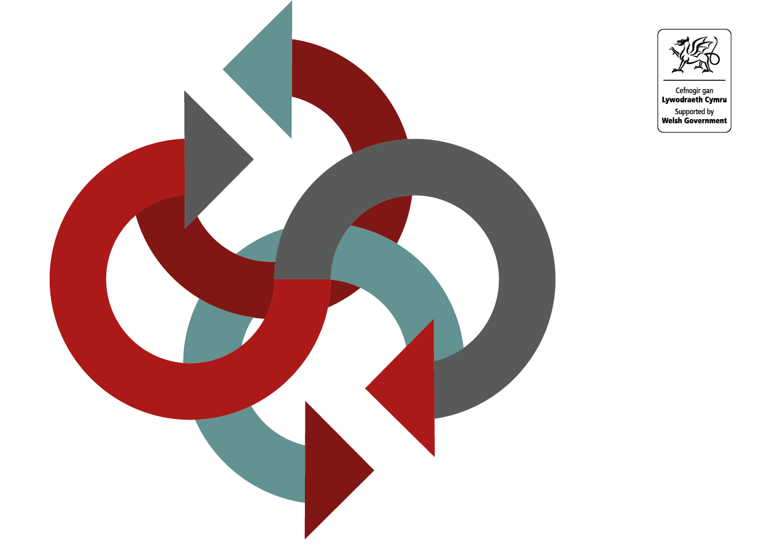

Version 5 (2021 Update)
Joint Controller Arrangement Checklist
Joint Controller Arrangement Checklist

Organisational Commitments

Introduction
Article 26 of the General Data Protection Regulation (UK GDPR) states that ‘where two or more controllers jointly determine the purposes and means of processing, they shall be joint controllers’. Similar provisions are included in section 58 of the Data Protection Act 2018 (DPA 18).
Joint controllers are required to establish an arrangement that sets out their respective responsibilities for compliance with UK GDPR. The format of the arrangement is not prescribed but it must be set out in a transparent manner or structure, which clarifies the respective responsibilities for compliance with UK GDPR, in particular regarding allowing data subjects to exercise their rights.
Owing to the varied nature of services and arrangements that could require such an arrangement, a standard template has not been produced. The checklist below sets out the key considerations when drafting a joint controller arrangement.
The checklist should not be considered as legal advice. You should seek advice from your Data Protection Officer or other suitably qualified person if you have any doubts about the nature of the relationship or the content of any arrangement.
The below checklist takes into account the requirements of joint controllers under article 26 of the UK GDPR and, section 58 of the DPA 18 where processing is for law enforcement purposes (defined under section 31 of the DPA 18).

JOINT CONTROLLER ARRANGEMENT CHECKLIST
PRE-ARRANGEMENT
Question / Consideration | Further guidance / notes | Check
Have you clarified the nature of the relationship between controllers? | Are you clear that the partners to the arrangement are ‘joint controllers’? If they are data controllers in their own right and whether an ISP or DDA (depending on the nature of the sharing) may be more appropriate.  Consider the flow chart ‘Why Type of Agreement is Required?’ | ☐

GENERAL CONSIDERATIONS WHEN DRAWING UP AN ARRANGEMENT
(see UK GDPR Article 26 & DPA 2018 Section 58)
Is the arrangement written in a transparent manner? | The arrangement should be not convoluted and lengthy. It should written in clear and plain language, as the ‘essence of the arrangement’ needs to be made available to data subjects. | ☐
Is the purpose of the arrangement clear? | Would a data subject understand the purpose of the arrangement as described in the arrangement; ie would they understand why personal data is being processed and the nature of the relationship between controllers?  If controllers are processing the same data for different purposes, they are not joint controllers. | ☐
Have you determined your respective data protection responsibilities? | Article 26 (UK GDPR) / Section 58 (DPA 2018) does not prescribe the content of an arrangement but does say that respective responsibilities for compliance with UK GDPR / DPA 2018 should be set out.  Particular emphasis is placed on the rights of data subjects and the duty to provide inform them about how their personal data is processed. | ☐
Have the controllers considered how the ‘essence’ of the arrangement be made available to data subjects? | This is a requirement of Article 26, paragraph 2. Controllers need to consider how data subjects will be informed. For example, this could be via each controller’s privacy notice or through publication of the arrangement itself.  While this is not a specific requirement of Section 58 DPA, joint controllers may wish to consider making the agreement available. | ☐

SPECIFIC CONSIDERATIONS TO INCLUDE IN AN ARRANGEMENT
Does the arrangement contain the following?
An introduction, providing a clear purpose of why it is necessary to process the information, the function and what the arrangement seeks to achieve? | This explanation should be written in a way that allows someone with no knowledge of the function or service to understand what it is about and why it is necessary to share the information. This will help in making your arrangement more transparent.  The purpose can be taken from your Data Protection Impact Assessment. | ☐
All of the organisations involved in the processing of the personal information and the roles and responsibilities of all involved? | All organisations involved in the sharing of personal information supported by this arrangement should be listed.  The arrangement should consider how the document is disseminated, whether each organisation is responsible for this or whether an allocated person takes on this responsibility.  Only data controllers should be listed in an arrangement. Data processing arrangements need to be addressed in a contract. | ☐
A designated contact point for data subjects? | This would help organisations demonstrate the key principle of ‘accountability’ under UK GDPR and DPA 2018.  In addition to providing a contact point, organisations should consider signing the document. | ☐
An appropriate lawful basis for processing personal information? | A lawful basis must be established prior to entering into any arrangements that involve the regular sharing of information. Without a clear legal basis organisations cannot demonstrate that they meet the first principle of UK GDPR (Article 5) and DPA 2018; ‘lawfulness, fairness and transparency’.  It is important you know whether processing is subject to the DPA 2018 or the UK GDPR - seek advice from your Information Governance leads / Data Protection Officer (or equivalent) if required.  The relevant sections of the ISP template and guidance may help you determine the appropriate legal basis. | ☐
Detail what information is being processed? | As data controllers, each organisation is responsible for ensuring only the minimum necessary personal information shared and is adequate, relevant and limited to what is required.  Anonymised and pseudonymised information should be used where possible. | ☐
How organisations will allow data subjects to exercise their rights? | Allowing data subjects to exercise their rights is an important part of complying with data protection legislation.  There is a focus on the ‘right to be informed’ (Article 12-14 of the UK GDPR, section 44 DPA2018), which is a core element of the principle of ‘lawfulness, fairness and transparency’. Ideally, this information – often provided in what is commonly referred to as a privacy notice - will be provided at the first point of contact. However, a layered approach is often appropriate. This could involve a high level organisational statement supplemented by specific service level information; for example a website or leaflet and verbal information provided by a practitioner.  Advice on individual rights is available via the Information Commissioner’s Office website.  The arrangement should detail whether there is a designated contact to answer data subjects’ requests or whether each organisation will consider their own requests and complaints. | ☐
How and when the information is shared and what methods are used to keep the information secure? | Organisations should ensure there are specific technical and organisational controls and safeguards in place to protect the personal information shared. This will ensure the appropriate consideration has been given to the security of personal information and demonstrate compliance with data protection legislation – namely paragraph 1 of article 24 of UK GDPR.  The arrangement should detail how each organisation should act in the event of a breach of security, confidentiality and other violations of the arrangement. It should detail what policies and procedures are in place, for example, where there is inaccurate data erased, to uphold the confidentiality, integrity and availability of personal information. Specific reference should be made to the retention, storage and disposal of records.  Consideration should be given to sharing the outcome of any investigation, where appropriate, with other partner organisations. It should be noted that partner organisations should make themselves aware of, and adhere to, their organisation’s Information Governance and records management procedures; in particular the provisions that relate to collecting, processing and disclosing personal information. | ☐

